Calculus I Name
Equations of Tangent Lines Block Date
Possible Slope Values
-7 0 12 24
Draw the slope of the tangent line at the following points. Then determine the best approximate slope at each value from the options in the answer bank.

a) x = -1 m = b) x = 0 m =
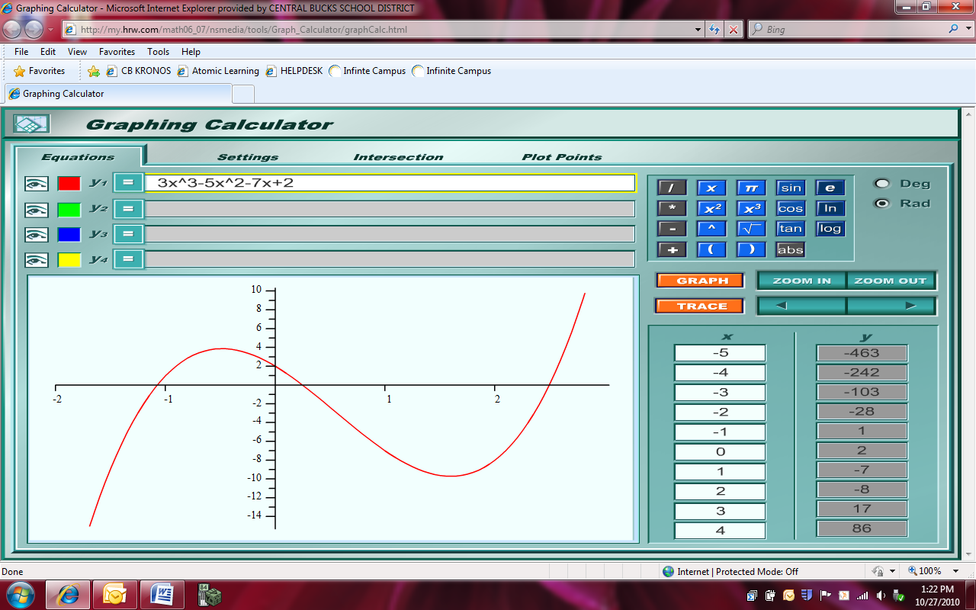

- x = 1.6 m = d) x = 2.5 m =

Using interval notation, determine the x-values where the graph is increasing. Estimate the x-values where it changes.

Using interval notation, determine the x-values where the graph is decreasing. Estimate the x-values where it changes.

The derivative is graphed below, compare the intervals above to the values of this graph.
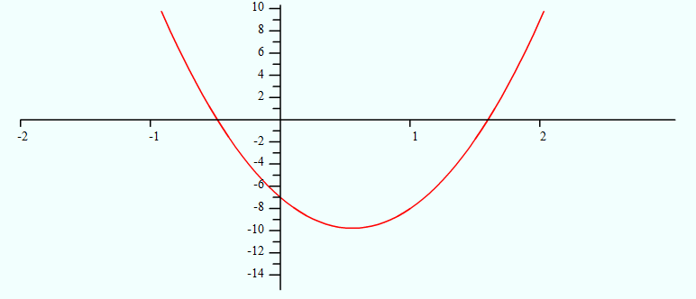
Can any conclusion be made?

Calculus I Name
Equations of Tangent Lines Block Date
Possible Slope Values
-7 0 12 24
Draw the slope of the tangent line at the following points. Then determine the best approximate slope at each value from the options in the answer bank.

a) x = -1 m = b) x = 0 m =

- x = 1.6 m = d) x = 2.5 m =

Using interval notation, determine the x-values where the graph is increasing. Estimate the x-values where it changes.

Using interval notation, determine the x-values where the graph is decreasing. Estimate the x-values where it changes.

The derivative is graphed below, compare the intervals above to the values of this graph.
Can any conclusion be made?

